**/​* PT1 Md Chowdhury Query#1 this query is for creating database */**

**DROP database**

**DROP database if exists airport;**

**CREATE DATABASE IF NOT EXISTS airport;**

**USE airport;**

**/​*PT1 Md Chowdhury Query#2 this query for creating table airplane*/**

**CREATE TABLE IF NOT EXISTS airplane**

**(**

**registrationnumber VARCHAR(10) NOT NULL,**

**airportname VARCHAR(50) NOT NULL,**

**capacity BIGINT NOT NULL default 0,**

**weight VARCHAR(20) NOT NULL,**

**modelnumber VARCHAR(20) NOT NULL**

**);**

**/​*PT1 Md Chowdhury Query#5 this query is for inserting data into airplane*/**

**Insert data into airplane**

**INSERT INTO airplane**

**VALUES ('JA8089',**

**'Miami International Airport',**

**'162',**

**'175,000 lb',**

**'737-800');**

**INSERT INTO airplane**

**VALUES ('NS4500',**

**'Miami International Airport',**

**'137',**

**'150,000 lb',**

**'737-700');**

**INSERT INTO airplane**

**VALUES ('D-BEAR',**

**'Miami International Airport',**

**'295',**

**'300,000 lb',**

**'757-200');**

**INSERT INTO airplane**

**VALUES ('N755NA',**

**'Miami International Airport',**

**'75',**

**'100,000 lb',**

**'CRJ700');**

**INSERT INTO airplane**

**VALUES ('F-WTSA',**

**'Miami International Airport',**

**'375',**

**'395,000 lb',**

**'767-300');**

**/​*PT1 Md Chowdhury Query#2 this query is for creating table employee*/**

**CREATE TABLE IF NOT EXISTS employee**

**(**

**ssn VARCHAR(100),**

**firstname VARCHAR(100),**

**lastname VARCHAR(100),**

**address VARCHAR(100),**

**city VARCHAR(100),**

**state VARCHAR(100),**

**zipcode VARCHAR(100),**

**cellnumber VARCHAR(100),**

**homenumber VARCHAR(100),**

**jobtitle VARCHAR(100),**

**salary bigint default 0,**

**airportname VARCHAR(100),**

**hiredate VARCHAR(100),**

**email VARCHAR(100) unique,**

**INDEX (Email DESC)**

**);**

**/​*PT1 Md Chowdhury Query#5 this query is for inserting data into employee */**

**INSERT INTO employee**

**VALUES ('291-299-9999',**

**'Jon',**

**'Snow',**

**'3655 Seaside Dr',**

**'Fort Lauderdale',**

**'FL',**

**'33301',**

**'305-687-3365',**

**'NULL',**

**'Pilot',**

**'110350',**

**'Miami International Airport',**

**'2011-04-17',**

**'Jsnow@gmail.com');**

**INSERT INTO employee**

**VALUES ('033-569-8722',**

**'Cersel',**

**'Lannister',**

**'1415 Rose St',**

**'Key West',**

**'FL',**

**'33040',**

**'786-560-8900',**

**'NULL',**

**'Air Traffic Controller',**

**'67350',**

**'Miami International Airport',**

**'2011-04-17',**

**'Clannister@gmail.com');**

**INSERT INTO employee**

**VALUES ('110-459-0865',**

**'Sanasa',**

**'Stark',**

**'2827 Harris Ave',**

**'Fort Lauderdale',**

**'FL',**

**'33301',**

**'305-980-5663',**

**'NULL',**

**'Aircraft Mechanic Technician',**

**'115879',**

**'Miami International Airport',**

**'2011-04-17',**

**'Sstark@aol.com');**

**INSERT INTO employee**

**VALUES ('110-352-0866',**

**'Tyrion ',**

**'Lannister',**

**'1415 Rose St',**

**'Key West',**

**'FL',**

**'33040',**

**'786-788-5400',**

**'NULL',**

**'Aircraft Mechanic Technician',**

**'53200',**

**'Miami International Airport',**

**'2011-04-17',**

**'TLan6969@gmail.com');**

**INSERT INTO employee**

**VALUES ('034-234-8799',**

**'Arya',**

**'Stark',**

**'2827 Harris Ave',**

**'Fort Lauderdale',**

**'FL',**

**'33301',**

**'305-333-0900',**

**'NULL',**

**'Flight Attendant',**

**'59400',**

**'Miami International Airport',**

**'2011-04-17',**

**'AStark11@aol.com');**

**INSERT INTO employee**

**VALUES ('055-450-8766',**

**'Bruce',**

**'Banner',**

**'1707 George St',**

**'Key West',**

**'FL',**

**'33040',**

**'646-549-1128',**

**'NULL',**

**'Aircraft Mechanic Technician',**

**'79500',**

**'Miami International Airport',**

**'2012-05-04',**

**'TheHulk@outlook.com');**

**INSERT INTO employee**

**VALUES ('090-344-8977',**

**'Tony',**

**'Stark',**

**'22 Hilton Haven Rd',**

**'Fort Lauderdale',**

**'FL',**

**'33301',**

**'786-300-2688',**

**'786-544-7622',**

**'Engineering IT Systems',**

**'174500',**

**'Miami International Airport',**

**'2012-05-04',**

**'ironman@gmail.com');**

**INSERT INTO employee**

**VALUES ('200-456-2377',**

**'Natasha',**

**'Romanoff',**

**'1510 18th St',**

**'Fort Lauderdale',**

**'FL',**

**'33301',**

**'646-899-6556',**

**'305-768-0855',**

**'Flight Dispatcher',**

**'51500',**

**'Miami International Airport',**

**'2012-05-04',**

**'Nromanoff@ymail.com');**

**INSERT INTO employee**

**VALUES ('101-432-5044',**

**'Peter',**

**'Parker',**

**'408 Porter Ln',**

**'Hollywood',**

**'FL',**

**'33004',**

**'646-345-6543',**

**'305-099-5211',**

**'Enginering IT Systems',**

**'100200',**

**'Miami International Airport',**

**'2012-05-04',**

**'spiderman@avengers.com');**

**INSERT INTO employee**

**VALUES ('098-348-1269',**

**'James',**

**'Rhodes',**

**'3213 Eagle Ave',**

**'Hollywood',**

**'FL',**

**'33004',**

**'929-067-4533',**

**'305-879-0988',**

**'Reservation Agent',**

**'53200',**

**'Miami International Airport',**

**'2012-05-04',**

**'warmachine@avengers.com');**

**INSERT INTO employee**

**VALUES ('190-987-7654',**

**'Professor',**

**'Xavier',**

**'1500 White St',**

**'Key West',**

**'FL',**

**'33040',**

**'305-904-3496',**

**'NULL',**

**'Air Traffic Controller',**

**'62400',**

**'Miami International Airport',**

**'2000-07-14',**

**'proffxavier@xmen.com');**

**INSERT INTO employee**

**VALUES ('290-456-8099',**

**'Jean',**

**'Gray',**

**'1026 Von Phister St',**

**'Key West',**

**'FL',**

**'33040',**

**'786-123-4881',**

**'NULL',**

**'Engineering IT Systems',**

**'101455',**

**'Miami International Airport',**

**'2000-07-14',**

**'darkphonix@xmen.com');**

**INSERT INTO employee**

**VALUES ('211-777-9324',**

**'Ororo',**

**'Munroe-storm',**

**'1500 White St',**

**'Key West',**

**'FL',**

**'33040',**

**'917-441-9512',**

**'NULL',**

**'Engineering IT Systems',**

**'165400',**

**'Miami International Airport',**

**'2000-07-14',**

**'iamstorm@xmen.com');**

**INSERT INTO employee**

**VALUES ('078-901-7542',**

**'Scott',**

**'Summers-cyclops',**

**'1026 Von Phister St',**

**'Key West',**

**'FL',**

**'33040',**

**'786-091-2964',**

**'NULL',**

**'Flight Attendant',**

**'64700',**

**'Miami International Airport',**

**'2000-07-14',**

**'sscyclopse@xmen.com');**

**INSERT INTO employee**

**VALUES ('174-884-2748',**

**'Erik',**

**'Lehnsherr Magneto',**

**'1500 White St',**

**'Key West',**

**'FL',**

**'33040',**

**'305-033-8222',**

**'NULL',**

**'Pilot',**

**'110350',**

**'Miami International Airport',**

**'2000-07-14',**

**'ELMagnito@xmen.com');**

**INSERT INTO employee**

**VALUES ('082-611-6580',**

**'Morty',**

**'Smith',**

**'827 Eisenhower Dr',**

**'Hialeah',**

**'FL',**

**'33002',**

**'646-049-6506',**

**'NULL',**

**'Flight Dispatcher',**

**'51500',**

**'Miami International Airport',**

**'2013-12-03',**

**'mortysmith@rickandmorty.com');**

**INSERT INTO employee**

**VALUES ('147-730-8799',**

**'Rick ',**

**'Sanchez',**

**'1724 Bahama Dr',**

**'Hialeah',**

**'FL',**

**'33002',**

**'917-498-2344',**

**'NULL',**

**'Pilot',**

**'110000',**

**'Miami International Airport',**

**'2013-12-03',**

**'Rsanchez@rickandmorty.com');**

**INSERT INTO employee**

**VALUES ('020-349-5444',**

**'Jerry',**

**'Smith',**

**'28 Seaside South Ct',**

**'Hialeah',**

**'FL',**

**'33002',**

**'646-209-7302',**

**'NULL',**

**'Reservation Agent',**

**'100500',**

**'Miami International Airport',**

**'2013-12-03',**

**'jsmith@rickandmorty.com');**

**INSERT INTO employee**

**VALUES ('111-888-3200',**

**'Bruce',**

**'Wayne',**

**'32 Hilton Haven Rd',**

**'Miami',**

**'FL',**

**'33101',**

**'929-141-3772',**

**'786-320-5400',**

**'Aircraft Mechanic Technician',**

**'69200',**

**'Miami International Airport',**

**'2016-03-25',**

**'Dawnofjustice@yahoo.com');**

**INSERT INTO employee**

**VALUES ('255-420-9211',**

**'Lex',**

**'Luthor',**

**'32 Hilton Haven Rd',**

**'Miami',**

**'FL',**

**'33101',**

**'978-458-2922',**

**'305-067-2311',**

**'Aircraft Mechanic Technician',**

**'69200',**

**'Miami International Airport',**

**'2016-03-25',**

**'lexluthor@gmail.com');**

**/​*PT1 Md Chowdhury Query#2 this query is for creating table flightdispatcher*/**

**CREATE TABLE IF NOT EXISTS flightdispatcher**

**(**

**ssn VARCHAR(100),**

**faacertifiedflightdispatcher VARCHAR(100),**

**yearsofexperience VARCHAR(100),**

**icaoexperience VARCHAR(100),**

**netgenexperience VARCHAR(100),**

**experienceinternationalflights VARCHAR(100),**

**doddispatchexperience VARCHAR(100),**

**mainlinecarrier VARCHAR(100)**

**);**

**/​*PT1 Md Chowdhury Query#2 this query is for creating table aircraftmechanictechnician*/**

**CREATE TABLE IF NOT EXISTS aircraftmechanictechnician**

**(**

**expertise VARCHAR(100),**

**ssn VARCHAR(100),**

**yearsofexperience VARCHAR(100)**

**);**

**/​*PT1 Md Chowdhury Query#2 this query is for creating table test*/**

**CREATE TABLE IF NOT EXISTS test**

**(**

**faaexamtype VARCHAR(100),**

**testname VARCHAR(100),**

**maxscore VARCHAR(100),**

**numberhours VARCHAR(100),**

**testscore bigint default 0,**

**ssn VARCHAR(100),**

**registrationnumber VARCHAR(100),**

**examdate VARCHAR(100)**

**);**

**/​*PT1 Md Chowdhury Query#2 this query is for creating table engineringitsystems*/**

**CREATE TABLE IF NOT EXISTS engineringitsystems**

**(**

**ssn VARCHAR(100),**

**degree VARCHAR(100)**

**);**

**/​*PT1 Md Chowdhury Query#2 this query is for creating table flightattendant*/**

**CREATE TABLE IF NOT EXISTS flightattendant**

**(**

**ssn VARCHAR(100),**

**degreetype VARCHAR(100),**

**over18 VARCHAR(100),**

**securityverification VARCHAR(100)**

**);**

**/​*PT1 Md Chowdhury Query#2 this query is for airtrafficcontroller*/**

**CREATE TABLE IF NOT EXISTS airtrafficcontroller**

**(**

**ssn VARCHAR(100),**

**medicalexam VARCHAR(100)**

**);**

**/​*PT1 Md Chowdhury Query#2 this query is for reservationagent*/**

**CREATE TABLE IF NOT EXISTS reservationagent**

**(**

**ssn VARCHAR(100),**

**yearofexperience VARCHAR(100),**

**degreetype VARCHAR(100),**

**over18 VARCHAR(100)**

**);**

**/​*PT1 Md Chowdhury Query#2 this query is for pilot*/**

**CREATE TABLE IF NOT EXISTS pilot**

**(**

**flightinstructor VARCHAR(100),**

**totalflighttime VARCHAR(100),**

**ssn VARCHAR(100),**

**airlinetransportpilotcertificate VARCHAR(100),**

**privatepilotcertificate VARCHAR(100),**

**faamedical VARCHAR(100),**

**multienginerating VARCHAR(100),**

**faawrittenexam VARCHAR(100),**

**degree VARCHAR(100)**

**);**

**/​*PT1 Md Chowdhury Query#5 this query is for inserting data into flightdispatcher*/**

**INSERT INTO flightdispatcher**

**VALUES ('082-611-6580',**

**'Yes',**

**'11',**

**'3',**

**'5',**

**'8',**

**'10',**

**'11');**

**INSERT INTO flightdispatcher**

**VALUES ('200-456-2377',**

**'Yes',**

**'10',**

**'3',**

**'3',**

**'5',**

**'8',**

**'10');**

**/​*PT1 Md Chowdhury Query#5 this query is for inserting data into aircraftmechanictechnician*/**

**INSERT INTO aircraftmechanictechnician**

**VALUES ('Turboprop and jet enginees',**

**'111-888-3200',**

**'10');**

**INSERT INTO aircraftmechanictechnician**

**VALUES ('Maintance and repair',**

**'110-459-0865',**

**'9');**

**INSERT INTO aircraftmechanictechnician**

**VALUES ('Electical system troubleshooting ',**

**'255-420-9211',**

**'4');**

**INSERT INTO aircraftmechanictechnician**

**VALUES ('Structual Repair',**

**'110-352-0866',**

**'3');**

**INSERT INTO aircraftmechanictechnician**

**VALUES ('Electical system troubleshooting ',**

**'055-450-8766',**

**'5');**

**/​*PT1 Md Chowdhury Query#5 this query is for inserting data into test*/**

**INSERT INTO test**

**VALUES ('361SG',**

**'Jet engine response and electric check',**

**'100',**

**'15',**

**'95',**

**'110-459-0865',**

**'JA8089',**

**'2019-03-24');**

**INSERT INTO test**

**VALUES ('363SG',**

**'Enginee speed stop and start time',**

**'100',**

**'25',**

**'97',**

**'110-352-0866',**

**'NS4500',**

**'2019-04-25');**

**INSERT INTO test**

**VALUES ('366SG',**

**'Overall aircaft electrial check',**

**'100',**

**'50',**

**'100',**

**'111-888-3200',**

**'D-BEAR',**

**'2019-05-26');**

**INSERT INTO test**

**VALUES ('373SG',**

**'Enginee speed stop and start time',**

**'100',**

**'30',**

**'100',**

**'055-450-8766',**

**'N755NA',**

**'2019-05-28');**

**INSERT INTO test**

**VALUES ('837SG',**

**'Jet engine response time',**

**'100',**

**'15',**

**'80',**

**'110-459-0865',**

**'F-WTSA',**

**'2019-06-03');**

**INSERT INTO test**

**VALUES ('857SG',**

**'Enginee max speed, start and delay time',**

**'100',**

**'5',**

**'85',**

**'255-420-9211',**

**'F-WTSA',**

**'2019-06-04');**

**INSERT INTO test**

**VALUES ('858SG',**

**'Aircaft enginee check',**

**'100',**

**'5',**

**'90',**

**'055-450-8766',**

**'JA8089',**

**'2019-06-04');**

**/​*PT1 Md Chowdhury Query#5 this query is for inserting data into engineringitsystems*/**

**INSERT INTO engineringitsystems**

**VALUES ('101-432-5044',**

**'Computer Science MS');**

**INSERT INTO engineringitsystems**

**VALUES ('090-344-8977',**

**'Engineering PHD ');**

**INSERT INTO engineringitsystems**

**VALUES ('290-456-8099',**

**'Engineering PHD ');**

**INSERT INTO engineringitsystems**

**VALUES ('211-777-9324',**

**'Computer Science MS');**

**/​*PT1 Md Chowdhury Query#5 this query is for inserting data into flightattendant*/**

**INSERT INTO flightattendant**

**VALUES ('034-234-8799',**

**'High School Diploma',**

**'Yes',**

**'Yes');**

**INSERT INTO flightattendant**

**VALUES ('078-901-7542',**

**'English BA',**

**'Yes',**

**'Yes');**

**/​*PT1 Md Chowdhury Query#5 this query is for inserting data into airtrafficcontroller*/**

**INSERT INTO airtrafficcontroller**

**VALUES ('190-987-7654',**

**'2019-05-12');**

**INSERT INTO airtrafficcontroller**

**VALUES ('033-569-8722',**

**'2017-09-16');**

**/​*PT1 Md Chowdhury Query#5 this query is for inserting data into reservationagent*/**

**INSERT INTO reservationagent**

**VALUES ('020-349-5444',**

**'7',**

**'English BA',**

**'Yes');**

**INSERT INTO reservationagent**

**VALUES ('098-348-1269',**

**'2',**

**'High School Diploma',**

**'Yes');**

**/​*PT1 Md Chowdhury Query#5 this query is for inserting data into pilot*/**

**INSERT INTO pilot**

**VALUES ('Yes',**

**'85000 hours',**

**'147-730-8799',**

**'Yes',**

**'Yes',**

**'Yes',**

**'15 hours',**

**'Passed',**

**'Aeronautical Engineering BS');**

**INSERT INTO pilot**

**VALUES ('No',**

**'1600 hours',**

**'291-299-9999',**

**'Yes',**

**'Yes',**

**'Yes',**

**'10 hours',**

**'Passed',**

**'English BA ');**

**INSERT INTO pilot**

**VALUES ('Yes',**

**'150550 hours',**

**'174-884-2748',**

**'Yes',**

**'Yes',**

**'Yes',**

**'15 hours',**

**'Passed',**

**'Physics MS');**

**/​*PT1 Md Chowdhury Query#6 this query is for Show all the tables in the database. */**

**show tables;**

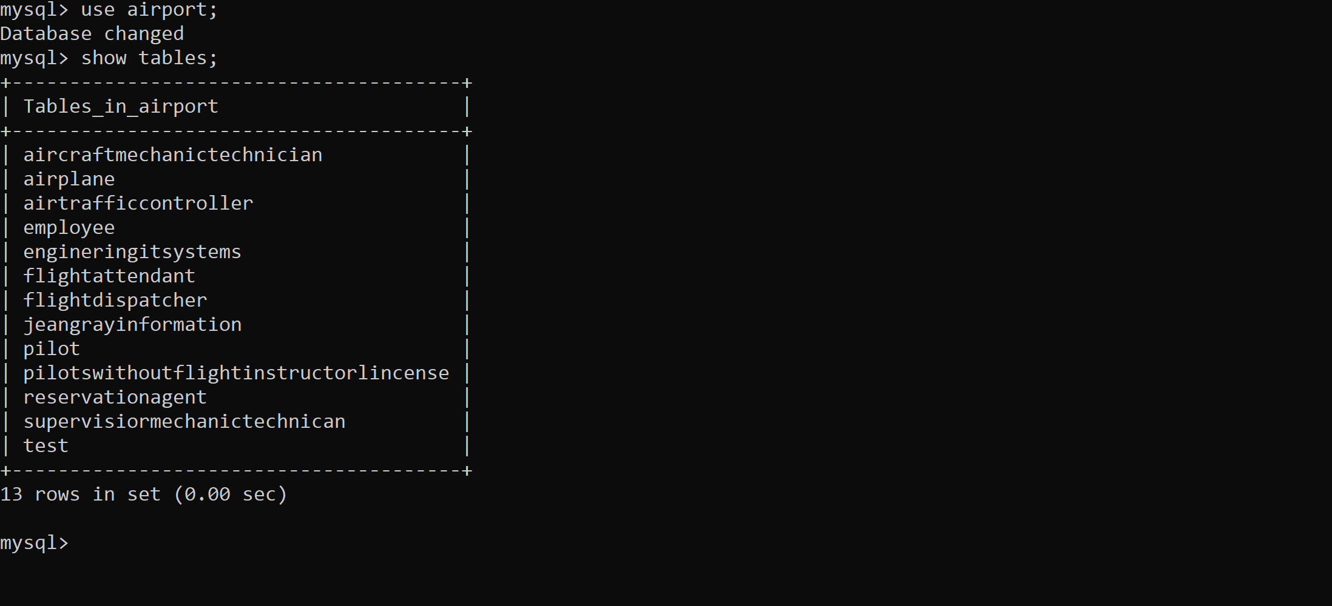

**/​*PT2 Md Chowdhury Query#1 this query is for Show all the employee data in the database. */**

**select * from employee;select * from employee;**

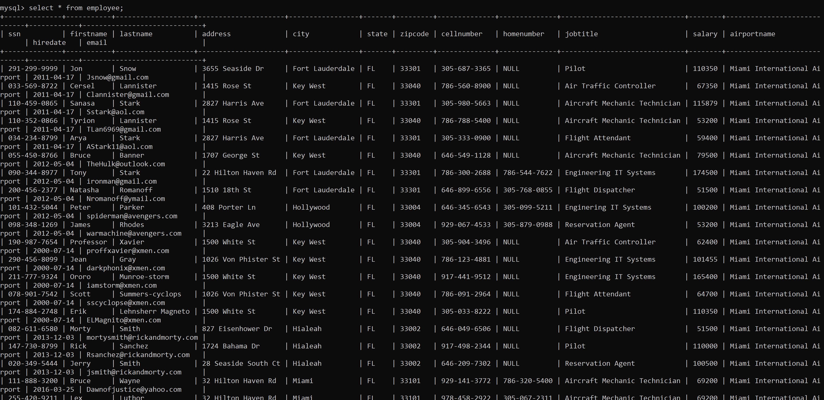

**/​*PT2 Md Chowdhury Query#2 this query is for showing the amount of employees that work for our airport. */**

**select count(*) from employee;**

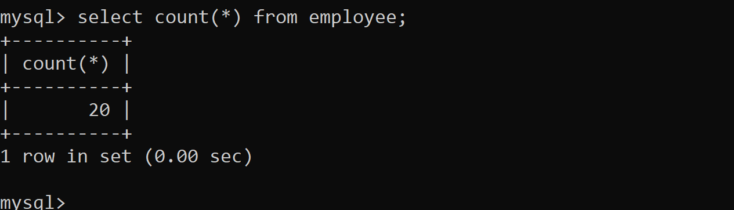

**/​*PT2 Md Chowdhury Query#3 this query is for showing the employees Full Name, job title and salary. Show me only the first 10 employees. ​Format their name, format salary to show as $30,000.00 and sort them by their job title in alphabetical order. */**

**select concat(firstname,' ', lastname) as 'Full Name',**

**jobtitle,**

**CONCAT('$', FORMAT(salary,2)) salary**

**from employee**

**order by jobtitle asc**

**limit 10;**

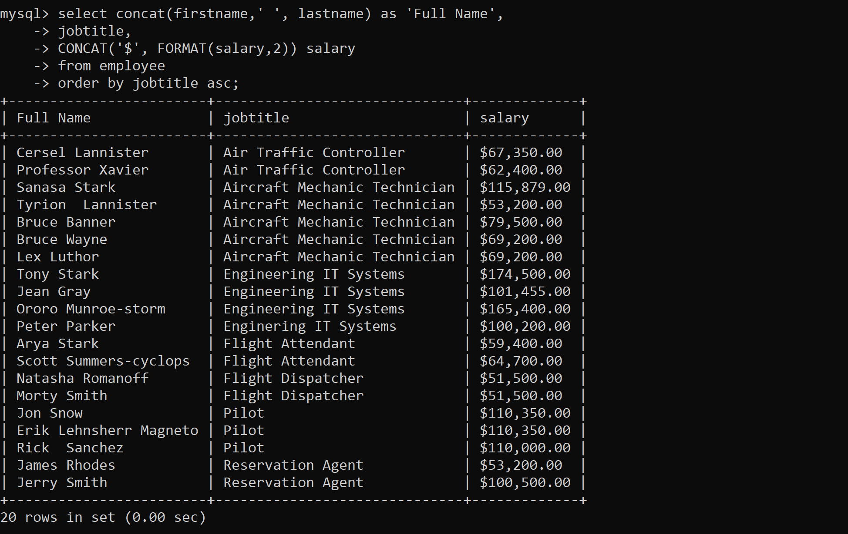

**/​*PT2 Md Chowdhury Query#4 this query is for showing the FAA exam type, test name, test score, registration number and exam date. Only show those whose test score is 85 and above and whose test name contains Enginee. */**

**select FAAexamtype, testname, testscore, registrationnumber, examdate**

**from test**

**where testscore >= 85**

**and testname like '%Enginee%';**

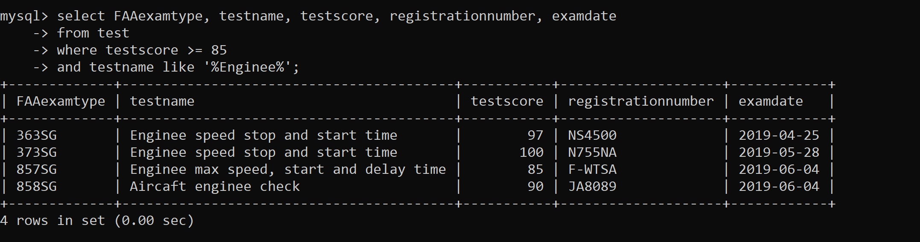

**/​*PT2 Md Chowdhury Query#5 this query is for showing the employees full name, their full address, email, job title, hire date and salary. ​You must format the full name of the employee and full address. */**

**select concat(firstname,' ', lastname) as 'Full Name',**

**concat(address, ',' ,city,',' ,state,',' ,zipcode) as 'Full Address',email,**

**jobtitle,**

**DATE_FORMAT(hiredate, "%M %d, %Y"),**

**CONCAT('$', FORMAT(salary,2)) salary**

**from employee**

**order by jobtitle asc;**

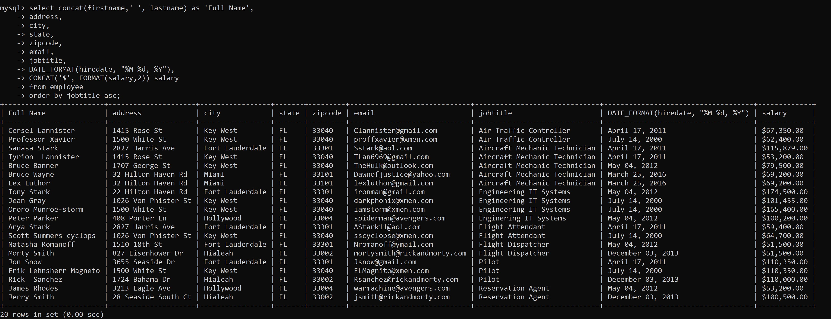

**/​*PT3 Md Chowdhury Query#1 this query is to show the first and last name of the employee, their job title, email, hire date, salary, and degree. ​You must also format their salary, ​Format the date the exam date */**

**select concat(firstname,' ', lastname) as 'Full Name',**

**jobtitle,**

**email,**

**DATE_FORMAT(hiredate, "%M %d, %Y") as Hiredate,**

**CONCAT('$', FORMAT(salary,2)) as salary**

**from employee, EngineringITSystems**

**where jobtitle = 'Engineering IT Systems'**

**and degree = 'Engineering PHD'**

**and employee.ssn = EngineringITSystems.ssn**

**order by concat(firstname,' ', lastname) asc;**

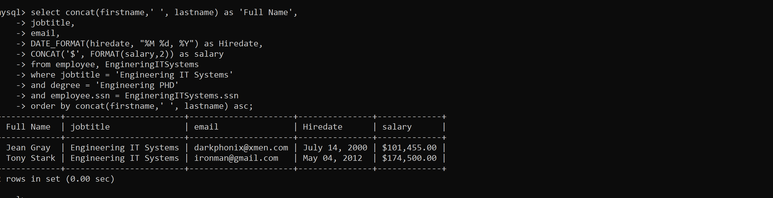

**/​*PT3 Md Chowdhury Query#2 this query is to show the full name of the employee, social security number, job title of the employee, the FAA exam type, test name, the number of hours worked on the test */**

**select concat(firstname,' ', lastname) as 'Full Name',**

**test.ssn,**

**jobtitle,**

**FAAexamtype,**

**testname,**

**numberhours,**

**registrationnumber,**

**DATE_FORMAT(examdate, "%M %d, %Y") as examdate,**

**testscore**

**from employee, test**

**where numberhours >= 25**

**and employee.ssn = test.ssn;**

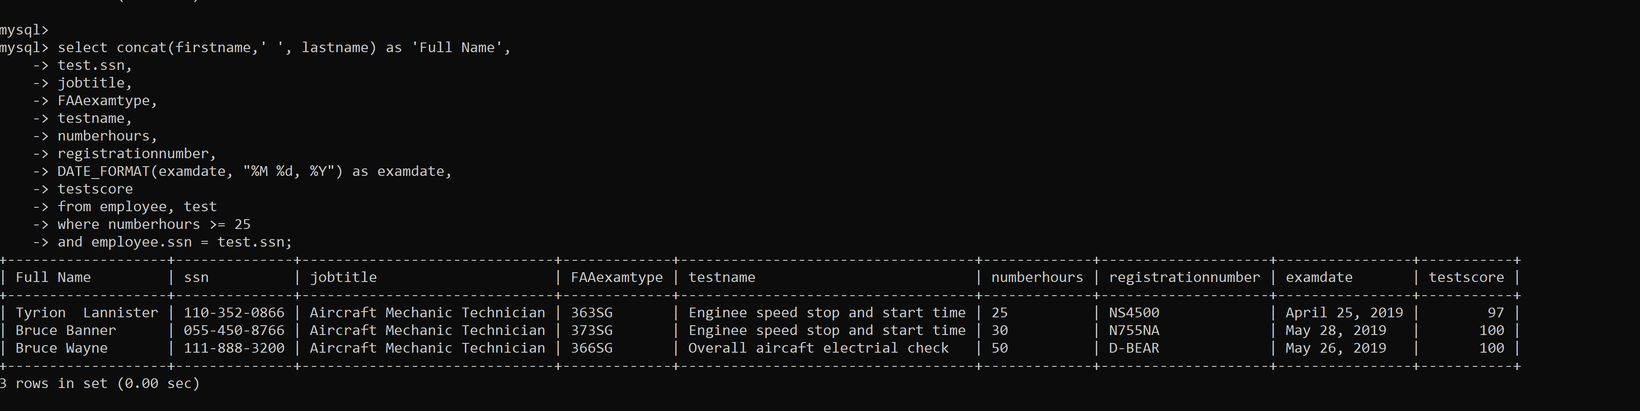

**/​*PT3 Md Chowdhury Query#3 this query is to show all the employees first and last name, email address, mobile number, salary job title, their expertise, their years of experience. We only want those employees */**

**select upper(firstname) as firstname,**

**upper(lastname) as lastname,**

**email,**

**address,**

**CellNumber,**

**CONCAT('$', FORMAT(salary,2)) salary,**

**jobtitle,**

**expertise,**

**YearsOfExperience**

**from employee, AircraftMechanicTechnician**

**where salary < 120000**

**and employee.ssn like '%8799'**

**and employee.ssn = AircraftMechanicTechnician.ssn**

**order by jobtitle asc;**

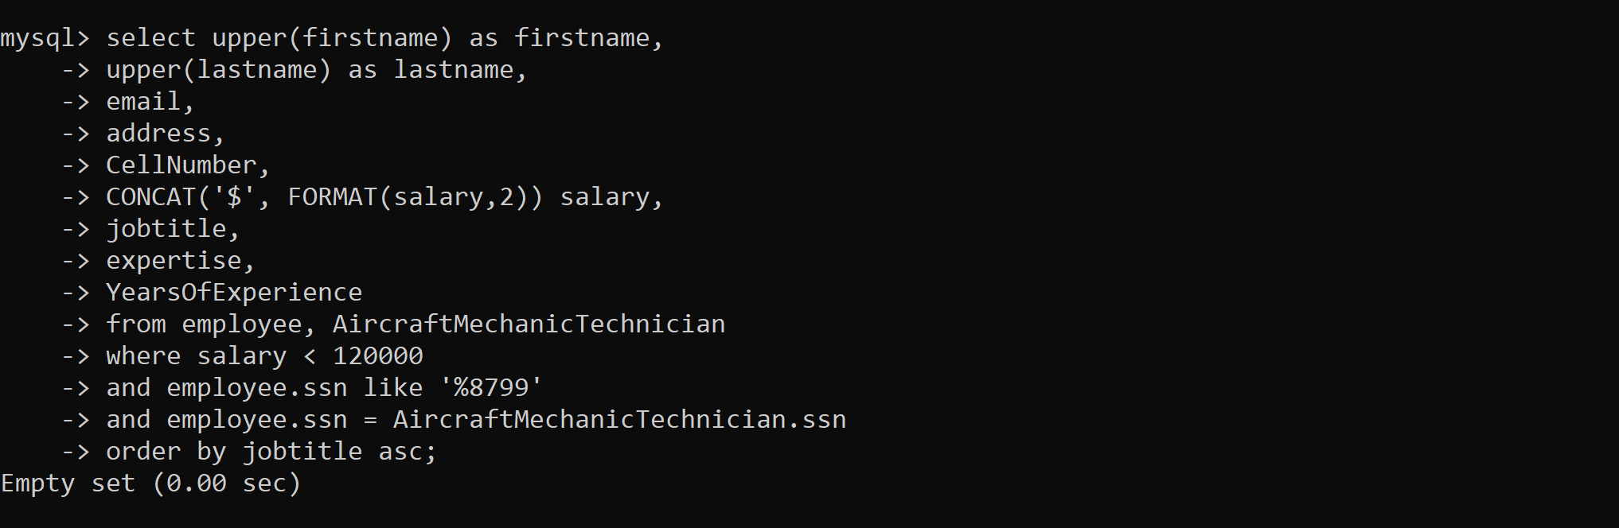

**/​*PT3 Md Chowdhury Query#4 this query is to show the airport name, the registration number, Model number of the plane, capacity of the plane, weight of the plane, FAA exam type, the Test name, their test score, the exam date, the full name of the employee performing the test.*/**

**select airplane.AirportName, airplane.RegistrationNumber, ModelNumber, Capacity, Weight, FAAExamType, testname, testscore,**

**DATE_FORMAT(examdate, "%M %d, %Y") as examdate,**

**concat(firstname,' ', lastname) as 'Full Name'**

**from airplane, test, employee**

**where airplane.registrationnumber = test.registrationnumber**

**and test.ssn = employee.ssn**

**order by firstname;**

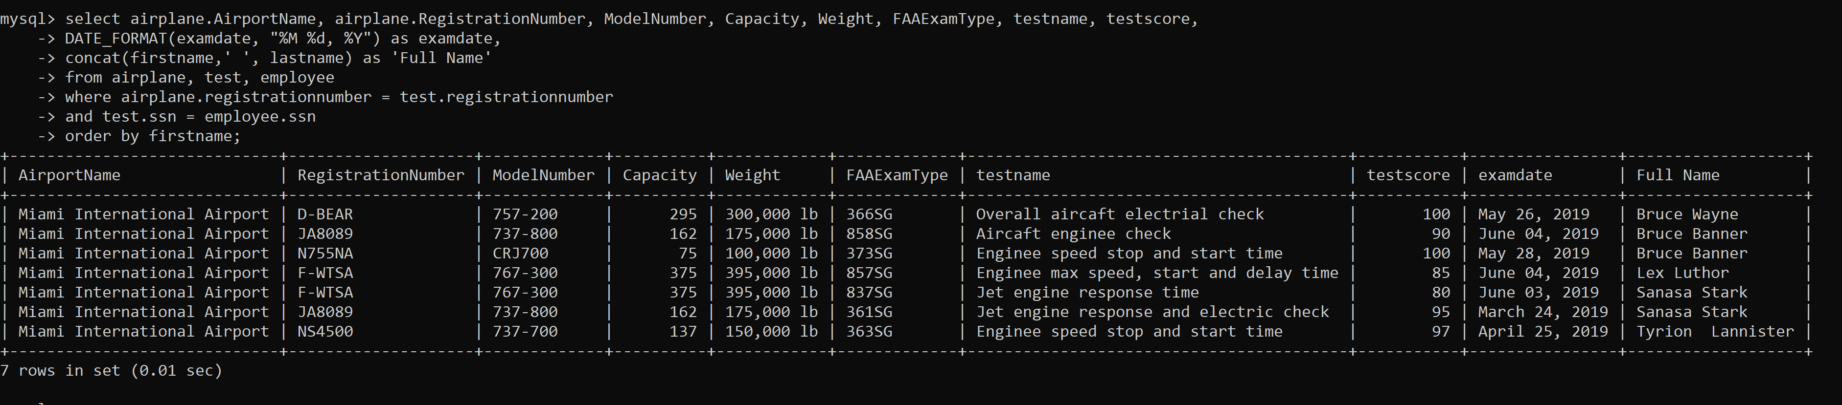

**/​*PT3 Md Chowdhury Query#5 this query is to show the social security number, first and last name, email , medical exam and of all our employees check to see if there exists a traffic controller who took their medical exam before 05/5/2019.​ ​*/**

**select employee.ssn,**

**firstname,**

**lastname,**

**email,**

**medicalexam**

**from employee, airtrafficcontroller**

**where STR_TO_DATE(medicalexam,'%d,%m,%Y') < STR_TO_DATE('5,5,2019','%d,%m,%Y')**

**and employee.ssn = airtrafficcontroller.ssn;**

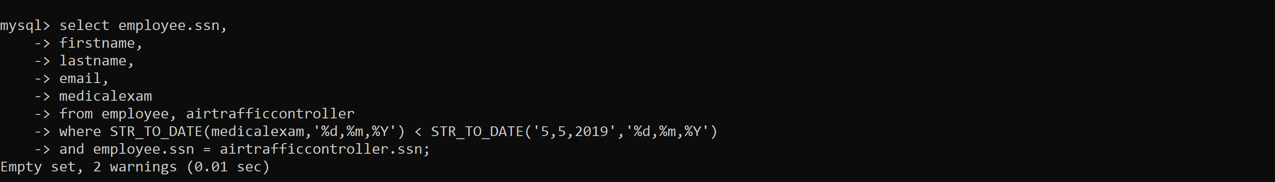

**/​*PT3 Md Chowdhury Query#6 this query is to show the FAA Exam Type the testname and the registration Number and test score. Also get the average test score and check to see which test scores are above that average. */**

**select FAAExamType, TestName, RegistrationNumber, TestScore, round(avg(TestScore),2)**

**from test**

**group by maxscore**

**having TestScore > avg(TestScore);**

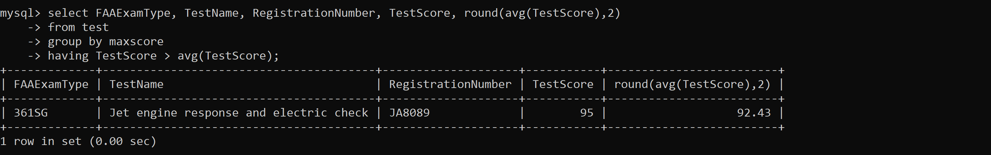

**/​*PT3 Md Chowdhury Query#7 this query is to show the full name and salary of the highest paid employee. ​*/**

**select concat(firstname,' ', lastname) as 'Full Name',**

**CONCAT('$', FORMAT(salary,2)) salary**

**from employee**

**where salary = (select max(salary) from employee);**

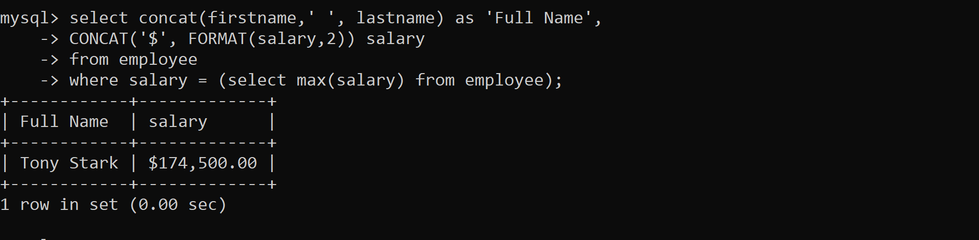

**/​*PT3 Md Chowdhury Query#8 this query is to show the first and last name, employee job title, their salary, the FAA exam type, the test name, test score and exam date.*/**

**select concat(firstname,' ', lastname) as 'Full Name',**

**jobtitle,**

**CONCAT('$', FORMAT(salary,2)) as salary,**

**FAAExamType, TestName, TestScore,**

**DATE_FORMAT(examdate, "%M %d, %Y") as examdate**

**from employee left outer join test**

**on employee.ssn = test.ssn;**

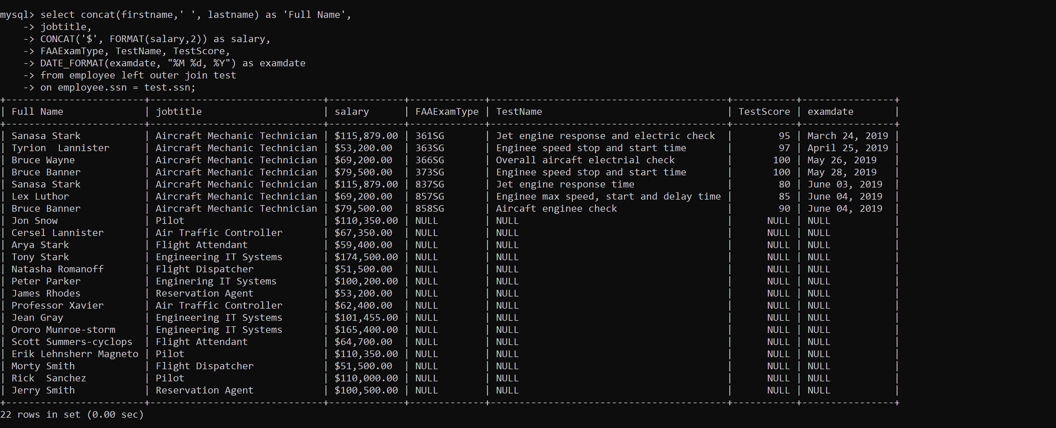

**/​*PT4 Md Chowdhury Query#1 Create a view for the mechanic technician supervisor.​ */**

**drop view if exists SupervisiorMechanicTechnican;**

**create view SupervisiorMechanicTechnican as**

**select concat(upper(firstname),' ', lastname) as 'Full Name',**

**jobtitle, count(testname) as 'Number of tests',**

**sum(numberhours) as 'Total hours'**

**from employee, test**

**where employee.ssn = test.ssn**

**group by test.ssn;**

**select * from SupervisiorMechanicTechnican;**

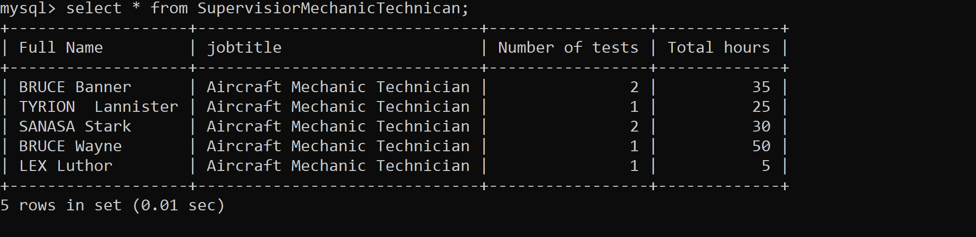

**/​*PT4 Md Chowdhury Query#2 this query is to create view PilotsWithoutFlightInstructorLincense*/**

**drop view if exists PilotsWithoutFlightInstructorLincense;**

**create view PilotsWithoutFlightInstructorLincense as**

**select upper(concat(firstname,' ', lastname)) as 'Full Name',**

**CellNumber,**

**email,**

**FlightInstructor,**

**TotalFlightTime,**

**AirlineTransportPilotCertificate,**

**FAAMedical,**

**FAAWrittenExam,**

**DATE_FORMAT(hiredate, "%M %d, %Y") as hiredate,**

**CONCAT('$', FORMAT(salary,2)) salary**

**from employee, pilot**

**where employee.ssn = pilot.ssn;**

**select * from PilotsWithoutFlightInstructorLincense;**

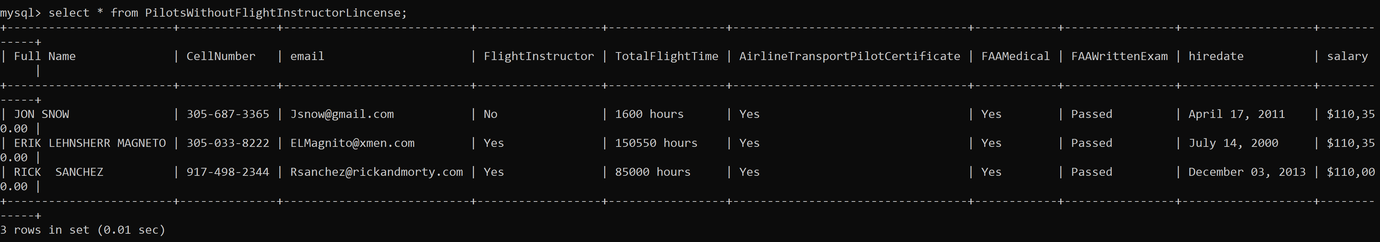

**/​*PT4 Md Chowdhury Query#3 this query is to create view JeanGrayInformation*/**

**drop view if exists JeanGrayInformation;**

**create view JeanGrayInformation as**

**select airportname,**

**SUBSTRING(employee.ssn, -4) as ssn,**

**upper(concat(firstname,' ', lastname)) as 'Full Name',**

**address,**

**city, state, zipcode,**

**CellNumber,**

**email,**

**jobtitle,**

**DATE_FORMAT(hiredate, "%M %d, %Y") as hiredate,**

**CONCAT('$', FORMAT(salary,2)) salary,**

**(0.05*salary) as bonus,**

**CONCAT('$', FORMAT(1.05*salary,2)) 'new salary'**

**from employee**

**where employee.firstname = 'Jean'**

**and employee.lastname = 'Gray';**

**select * from JeanGrayInformation;**

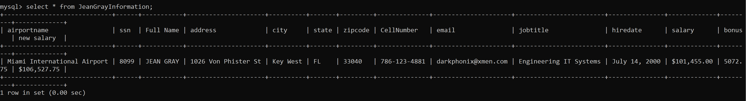

**Part-5**

1. **What is a database and RDBMS? Provide 3 examples of how you are using a database.**

Answer.

Database is a collection of information organized in a systematic way so that it can be easily accessed and managed. For example, in big firms which have huge number of employees use database to store information of their employees for easy accessibility and manipulation.

RDBMS stands for Relational Database Management System is a software system which stores data in a structured format using rows and columns. For example: MySQL, Oracle, IBM DB2, etc.

Examples of using database are:

* Online shopping list.
* Banking Transactions.
* Medical records.

1. **What is a primary key, foreign key, super key, composite key, alternate key, and unique key and provide an example for each.**

Answer.

* Primary Key –Primary key is a candidate key with no null values. Candidate key is any key with which can uniquely identify any record of a table.

For example-

Table- DEPARTMENT

|  |  |  |
| --- | --- | --- |
| DEPARTMENT ID | DEPARTMENT NAME | ADDRESS |
| D1 | ABS | - |
| D2 | XYZ | - |

In the above table, let the department id be primary key, therefore each record in the field of department id should be unique and there should be no null values.

* Foreign key – It is an attribute or set of attributes that references to primary key of same table or another table.

For example- In the below table, let us take some data of employees with reference to department id (primary key) from the department table. Therefore, department id in the below table of employee is the foreign key.

Table- EMPLOYEE

|  |  |  |  |
| --- | --- | --- | --- |
| EMPLOYEE ID | EMPLOYEE NAME | ADDRESS | DEPARTMENT ID |
| E1 | ABX | - | D1 |
| E2 | VGF | - | D2 |

* Super key – It is a set of attributes within a table that can uniquely identify each record within the table.
* Composite key –A key which has multiple attributes to uniquely identify rows in a table is a composite key. Attributes which together form a composite key are not independent of each other.
* Alternate key – An alternate key is one which his associated with one or more columns whose values uniquely identify every **row** in the **table**, but which is not the **primary key**.
* Unique key – enforces the Uniqueness of the values (i.e. avoids duplicate values) on the column[s] on which it is defined. Also these key’s can Uniquely identify each row in database table. Only one null value is allowed.

1. **What is Generalization and Specialization?**

Answer.

Generalization: Generalization is the process of extracting common properties from a set of entities and create a generalized entity from it. It is a bottom-up approach in which two or more entities can be generalized to a higher level entity if they have some attributes in common.

Specialization: In specialization, an entity is divided into sub-entities based on their characteristics. It is a top-down approach where higher level entity is specialized into two or more lower level entities.

1. **What is database normalization and what types of abnormalities exist if we do not normalize the database?**

Answer.

Database normalization is the process of restructuring a relational database in accordance with a series of so-called normal forms in order to reduce data redundancy and improve data integrity. It was first proposed by Edgar F. Codd as an integral part of his relational model.

Denormalization usually speeds retrieval but can slow updates.

Denormalization is always application-specific and needs to be re-evaluated if the application changes.

Denormalization can increase the size of tables. This is not a problem in Sybase IQ, because you can optimize the storage of column data. For details, see the IQ UNIQUE column constraint in CREATE TABLE statement and “MAX_QUERY_TIME option” in Reference: Statements and Options.

1. **What is an entity and attribute? Provide an example for each.**

Answer.

Attributes describe the characteristics or properties of an entity in a database table. An entity in a database table is defined with the 'fixed' set of attributes. For example, if we have to define a **student** entity then we can define it with the set of attributes like roll number, name, course

1. **What is the purpose of an inner join, left outer join and right outer join?**

Answer.

**Inner Join:** An Inner Join returns only the rows that have matching values in both the tables (we are considering here the join is done between the two tables).

**Left Outer Join**: Returns all the rows from the LEFT table and matching records between both the tables.

**Right Outer Join**: Returns all the rows from the RIGHT table and matching records between both the tables.

1. **What is an index?**

Answer.

Indexes are special lookup tables that the **database** search engine can use to speed up data retrieval. Simply put, an **index** is a pointer to data in a table. An **index** in a **database** is very similar to an **index** in the back of a book.

1. **What is a stored procedure?**

Answer.

A **stored procedure** is a set of Structured Query Language (SQL) statements with an assigned name that **are stored** in a RDBMS as a group such that it **can** be reused and shared by multiple programs.

1. **What are views? What is the purpose of views?**

Answer.

A **database** view is a searchable object in a **database** that is defined by a query. Though a view doesn't store data, some refer to a **views** as “virtual tables,” you can query a view like you can a table. A view can combine data from two or more table, using joins, and also just contain a subset of information.

The main **purpose** of a view in SQL is thus to combine data from multiple sources in a useful way without having to create yet another database table to store that data.

1. **What is the difference between NoSQL and SQL and list 2 types of SQL and NoSQL databases.**

Answer.

|  |  |  |
| --- | --- | --- |
| **Parameter** | **SQL** | **NOSQL** |
| Definition | SQL databases are primarily called RDBMS or Relational Databases | NoSQL databases are primarily called as Non-relational or distributed database |
| Design for | Traditional RDBMS uses SQL syntax and queries to analyze and get the data for further insights. They are used for OLAP systems. | NoSQL database system consists of various kind of database technologies. These databases were developed in response to the demands presented for the development of the modern application. |
| Query Language | Structured query language (SQL) | No declarative query language |
| Example | Oracle | MongoDB |
|  |  |  |

1. **What is DDL, DML and DCL and provide an example for each?**

Answer.

**DML:**

DML stands for Data Manipulation Language. It is used to retrieve, store, modify, delete, insert and update data in database.

SELECT – Retrieves data from a table  
INSERT –  Inserts data into a table  
UPDATE – Updates existing data into a table  
DELETE – Deletes all records from a table

**DDL:**

DDL stands for Data Definition Language. It is used to create and modify the structure of database objects in database.

CREATE – Creates objects in the database  
ALTER – Alters objects of the database  
DROP – Deletes objects of the database  
TRUNCATE – Deletes all records from a table and resets table identity to initial value.

**DCL:**

DCL stands for Data Control Language. It is used to create roles, permissions, and referential integrity as well it is used to control access to database by securing it.

GRANT – Gives user’s access privileges to database  
REVOKE – Withdraws user’s access privileges to database given with the GRANT command

1. **What is a subquery, and what is the main difference between a Subquery and Joins?**

Answer.

A Subquery or Inner query or a Nested query is a query within another SQL query and embedded within the WHERE clause.

A subquery is used to return data that will be used in the main query as a condition to further restrict the data to be retrieved.

[Subqueries](https://www.essentialsql.com/get-ready-to-learn-sql-server-19-introduction-to-sub-queries/) can be used to return either a scalar (single) value or a row set; whereas, joins are used to return rows.

1. **What are hierarchy, network and object oriented databases? What are their differences?**

Answer.

**1. Hierarchical databases**

In a hierarchical database model, the data is organized into a tree-like structure. In simple language we can say that it is a set of organized data in tree structure.

**2. Network databases**

This is looks like a Hierarchical database model due to which many time it is called as modified version of Hierarchical database. Network database model organized data more like a graph and can have more than one parent node. The network model is a database model conceived as a flexible way of representing objects and their relationships.

**4. Object-oriented databases**

An object database is a system in which information is represented in the form of objects as used in object-oriented programming.The object-oriented data model is based on the object-oriented- programming language concept, which is now in wide use. Inheritance, polymorphism, overloading. object-identity, encapsulation and information hiding with methods to provide an interface to objects, are among the key concepts of object-oriented programming that have found applications in data modelling. The object-oriented data model also supports a rich type system, including structured and collection types.

Below are the differences:

**Hierarchical model**

1. One to many or one to one relationships.
2. Based on parent child relationship.
3. Retrieve algorithms are complex and asymmetric
4. Data Redundancy more

**Network model**

1. Many to many relationships.
2. Many parents as well as many children.
3. Retrieve algorithms are complex and symmetric
4. Data Redundancy more

**Object Oriented model**

1. One to One,One to many, Many to many relationships.
2. Based on relational data structures.
3. Retrieve algorithms are simple and symmetric
4. Data Redundancy less